Assignment 1
Creating sample tables and inserting values.
Create the following tables with the given structures and insert sample data as specified: -
- SALESPEOPLE :
mysql> Create table SALESPEOPLE
-> (
-> Snum int(4),
-> Sname varchar(10),
-> City varchar(10),
-> Comm float(3,2)
-> );

mysql> insert into SALESPEOPLE values
-> (1001, 'Peel', 'London', .12),
-> (1002, 'Serres', 'San Jose', .13),
-> (1004, 'Motika', 'London', .11),
-> (1007, 'Rifkin', 'Barcelona', .15),
-> (1003, 'Axelrod', 'New York', .10);

mysql> select * from SALESPEOPLE;

Output:
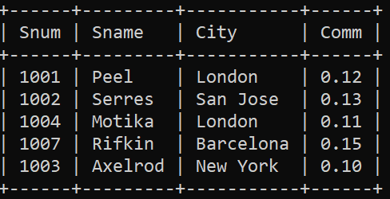
- CUSTOMERS :
mysql> create table CUSTOMERS
-> (
-> Cnum int(4),
-> Cname varchar(10),
-> City varchar(10),
-> Rating int(4),
-> Snum int(4)
-> );
mysql> insert into CUSTOMERS values
-> (2001, 'Hoffman', 'London', 100, 1001),
-> (2002, 'Giovanni', 'Rome', 200, 1003),
-> (2003, 'Liu', 'San Jose', 200, 1002),
-> (2004, 'Grass', 'Berlin', 300, 1002),
-> (2006, 'Clemens', 'London', 100, 1001),
-> (2008, 'Cisneros', 'San Jose', 300, 1007),
-> (2007, 'Pereira', 'Rome', 100, 1004);

mysql> select * from CUSTOMERS;
Output:
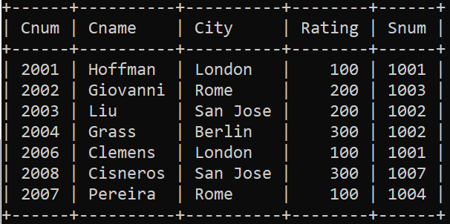
- ORDERS:
mysql> Create table ORDERS
-> (
-> Onum int(4),
-> Amt float(7,2),
-> Odate date,
-> Cnum int(4),
-> Snum int(4)
-> );

mysql> Insert into ORDERS values
-> (3001, 18.69,'1990-10-03', 2008, 1007),
-> (3003, 767.19,'1990-10-03', 2001, 1001),
-> (3002, 1900.10, '1990-10-03', 2007, 1004),
-> (3005, 5160.45, '1990-10-03', 2003, 1002),
-> (3005, 5160.45, '1990-10-03', 2003, 1002),
-> (3006, 1098.16, '1990-10-03', 2008, 1007),
-> (3009, 1713.23, '1990-10-04', 2002, 1003),
-> (3007, 75.75, '1990-10-04', 2004, 1002),
-> (3008, 4723.00, '1990-10-05', 2006, 1001),
-> (3010, 1309.95, '1990-10-06', 2004, 1002),
-> (3011, 9891.88, '1990-10-05', 2006, 1001);

mysql> select * from ORDERS;

Output:

